FlashPro Express RISCV Guide v1.0
Guide

15th February 2017
Rev 1.0
Revision History
Revision | Date | Description
1.0 | 15th February 2017 | Initial Draft

Table of Contents
1 Introduction 4
1.1 Abbreviation and Acronym 4
1.2 Reference Documents 4
2 Design Requirements 5
3 Demo Design 5
4 Board Setup 5
5 FlashPro Express 6

Introduction
This document is written to demonstrate how to use FlashPro Express with RISCV. It will show a user the steps involved in downloading a FlashPro Express project to board. For this guide the M2S090 Security Evaluation Kit and the FlashPro Express project found on the M2S090 Github page linked below.

Abbreviation and Acronym
Following table contains basic acronyms which will be used in all documents related to the FlashPro Express guide.

Acronym | Details
FPExpress | FlashPro Express

Reference Documents
This section contains the reference documents mentioned in the document.
Document ID | Document Name | Document Location
[R0] | Microsemi SmartFusion2 Security Development Kit | https://www.microsemi.com/products/fpga-soc/design-resources/dev-kits/smartfusion2/sf2-evaluation-kit
[R1] | M2S090-Security-Eval-Kit Github SF2_CoreRISCV_AXI4_BaseDesign | https://github.com/RISCV-on-Microsemi-FPGA/M2S090-Security-Eval-Kit

Design Requirements
Table 1 shows the design requirements.
Design Requirements | Description
Hardware Requirements
SmartFusion2 SoC FPGA M2S090 Security Evaluation Kit | Rev D or later
FlashPro5 Programmer or later | -
Power Adapter | 12V
USB A to mini-B USB Cable | -
Operating System | RHEL 6 64-bit  CentOS 6 64-bit  Windows 8 64-bit  Windows 7 Professional
Software Requirements
Microsemi FlashPro Express | Version 11.7 SP2

Demo Design
The demo design is available for downloading from the following path on the RISCV-on -Microsemi-FPGA Github page:
https://github.com/RISCV-on-Microsemi-FPGA/M2S090-Security-Eval-Kit
Download the files as a .zip file by selecting “Clone or Download” then by selecting “Download ZIP”. Extract the ZIP to a local directory such as:
C:\Users\user\Desktop\RISCV_FPEXPRESS_DEMO\

Board Setup
The M2S090 Security Development Kit should be set up as follows.
- Check if On/Off switch is in the Off position
- Plug in power cable to wall outlet and to the DC jack on the board
- Attach the ribbon cable supplied with the FlashPro5, to the FlashPro5 and to the JTAG Programming Header
- Attach the USB A to mini-B to the FlashPro5 and to the PC
- Power on the board using the ON/OFF switch

If the setup has been completed correctly it should look as follows:
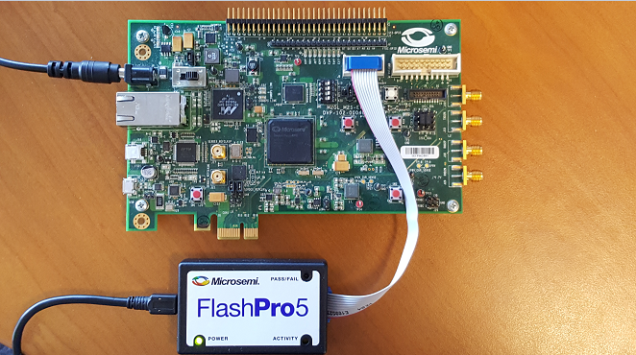
Figure 1

FlashPro Express
With the board connected and powered on open FlashPro Express Start -> All Programs -> Microsemi -> Libero 11.7 -> Program Debug -> FPExpress. The following screen should now be open on your monitor.
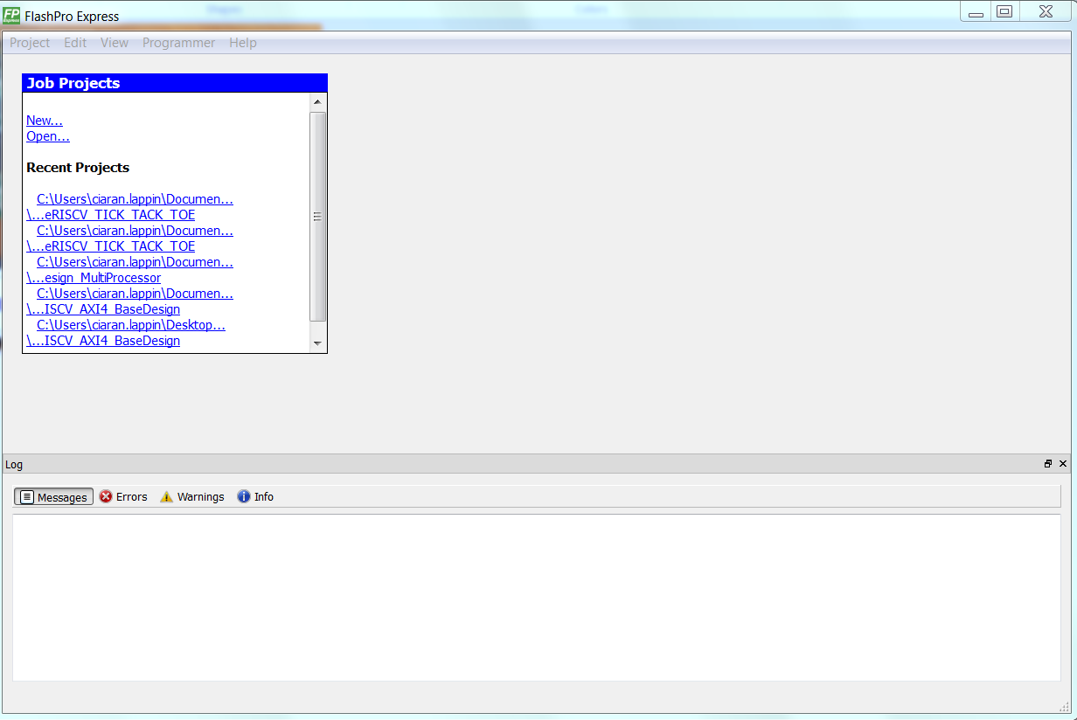
Figure 2
Next, click Project -> Open Job Project (.pro) and open the FPExpress Project located in:
C:\Users\user\Desktop\RISCV_FPEXPRESS_DEMO\M2S090-Security-Eval-Kit-master\ M2S090-Security-Eval-Kit-master\FlashProExpress\SF2_CoreRISCV_AXI4_BaseDesign
If the project opened successfully the following should be seen on the monitor.
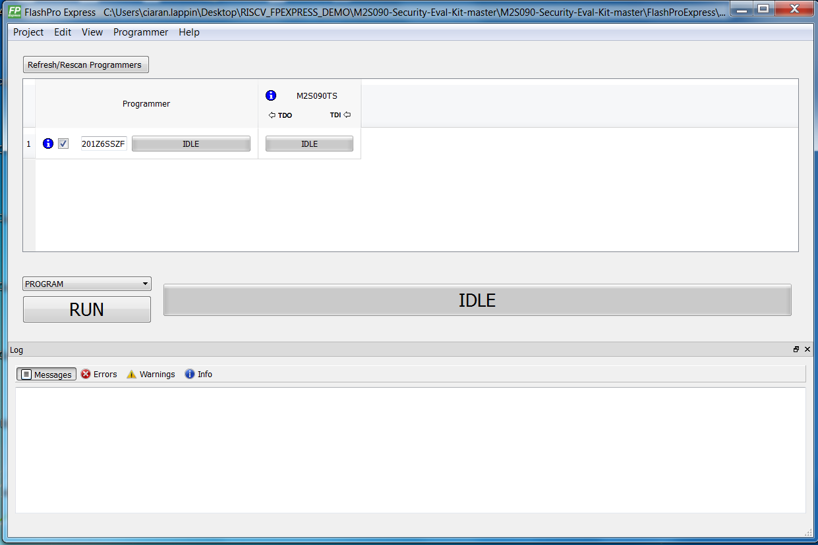
Figure 3
If the project doesn’t open successfully, the following may be seen on the monitor
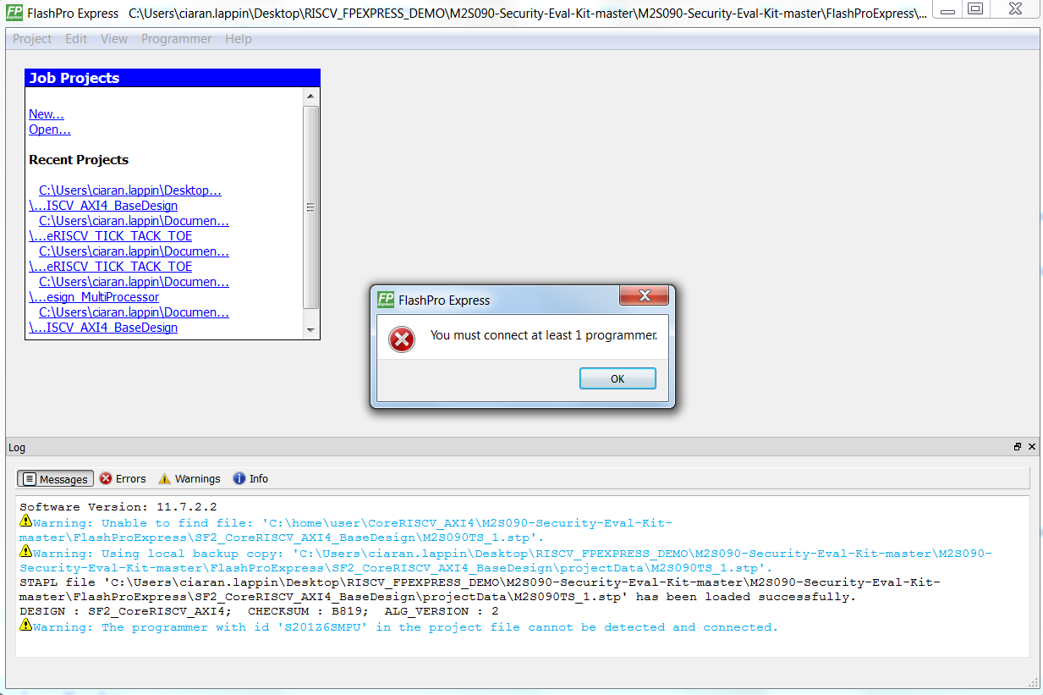
Figure 4
Check that the cable going into the FlashPro5 is connected properly, if it is slightly sticking out of the port it will not connect relieably.
Next, click “RUN”. Once complete you should see “1 PROGRAMMERS(s) PASSED” written instead of “IDLE” on the bar next to the “RUN” button.
Once successfully downloaded the board should looks as follows.

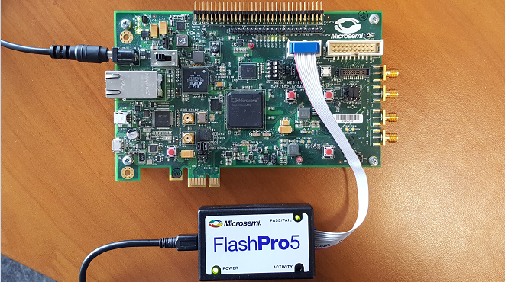
Figure 5
Some of the LEDs should be illuminated, as there is a program in the ENVM of the design.

Now that this is complete, firmware can be created using SoftConsole v5.0. This is available to download from:
https://www.microsemi.com/products/fpga-soc/soc-processors/risc-v
Sample applications for SoftConsole v5.0 can be found on the Github link below. The projects will be in the examples folder.
https://github.com/RISCV-on-Microsemi-FPGA/riscv-junk-drawer

